**Write a JSF project which contains 2 web page first one is called *index.xhtml*, and contains a form as shown.**

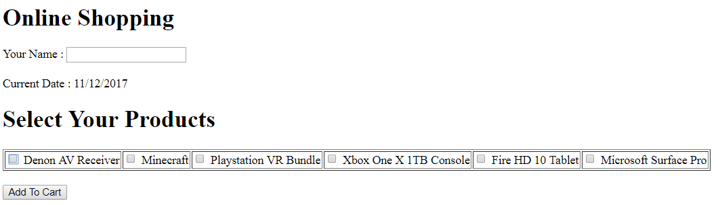

1. User must enter his name.
2. User select products, he wants.
3. Then user press “**Add to Cart”** button.
4. When user press **“Add to Cart”** button you should display his name, the date of adding the user products to the cart and the content of his cart in second page called “**cartPage”.**

You must do the following:

1. You must create a managed bean called **UserCart.java** that can handle user name, the date of adding the user products to cart and an array to handle cart content (selected products).
2. You must display the current Date in **(dd/MM/yyyy)** format in **“index.xhtml”** as shown in the figure.

**Test Example**:

“Index.xhtml “ page

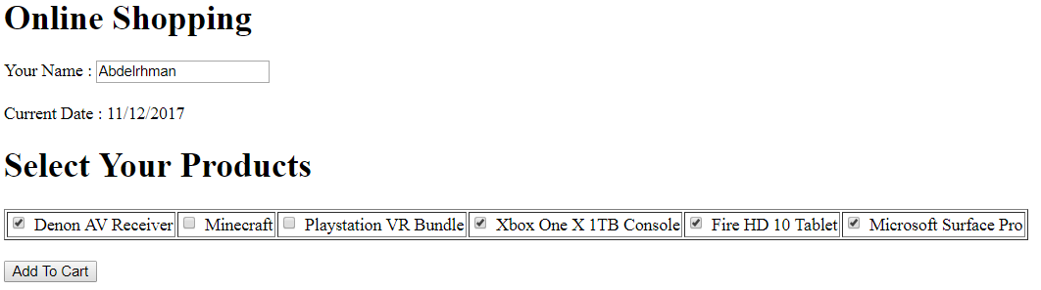

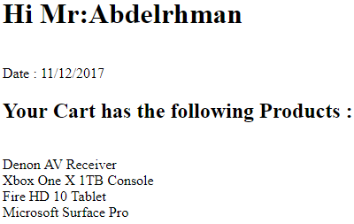

“Cart.xhtml” page